Payment Instructions for Parking Fees

Go to www.myschoolbucks.com from a computer
Login into your account or create an account
Go to the SCHOOL STORE
BROWSE ALL ITEMS
If you have multiple students at different locations you may have to FILTER BY SCHOOL, located in the upper left-hand corner of the screen, the choose FAIRFAX HS.
Look for this icon (you may have to go through multiple pages)
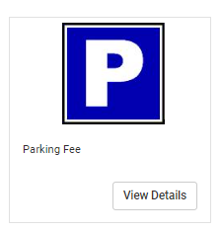
Click view details
Choose your student from the drop down
Add to cart
Start the checkout process.
************************************************************************************
FYI:
- You cannot use a school email to set up your account.
- Once you have created an account you need to add your student.
- There are two places to access fees: the first is the invoices folder on your main screen and the other is in the school store. This fee is in the school store and the directions are above.

