2020 FCPS Senior Survey Instructions
Please read the directions before answering the survey and take you time. Once you hit SUBMIT, you cannot go back and change your information
Your answers are based on your plans for the Fall of 2020, not your long-term plans
Question 1: What is your post-graduation plan? Choose only ONE, but not any that have been crossed out
Undetermined

2yrcollege

4yr college

Career Education

Military

Employed

Other

Dropped Out

College Prep School

Year Off

Non-US College
Undecided/No Plans
Apprenticeship Program

STEP, Pulley, Davis, Americorps (put the name of the program in the Comment Field)

Enlisting in Army, Air Force, Navy, Marines, Coast Guard, National Guard (NOT ROTC or Service Academies) Use the Comment Field to identify which branch of service
You plan to work, but are not taking classes at the same time

Returning to FHS next year, or not graduating by August 2020. (Use Comment Field to describe plans)

Naval Academy Prep School, Fork Union Prep Academy

Only use this option if you have been accepted for admission to a college but have been approved by the college to take the year off

Working in an apprenticeship program for a trade, such as electrician, plumber, contractor (use the Comment Field to identify which program)

Question 2: College results
List all the colleges you have applied to. The schools already listed are ones that you have submitted on a Transcript Request Form. If you applied to a college that is not listed, you can add the college by clicking on Add new and start typing the name, then select the school. When adding NOVA, type Northern Virginia Community College and select the Annandale Campus. If you are adding a school that you will be attending, you must complete a Transcript Request Form and email it to Mrs. Scibilia at ddscibilia@fcps.edu in order for you to have your final transcript sent to that school.
Check send final transcript for the school you will be attending. In addition to your attending school, you can also check the send final transcript box for NCAA or any school you are waitlisted and wish to stay on the waitlist.

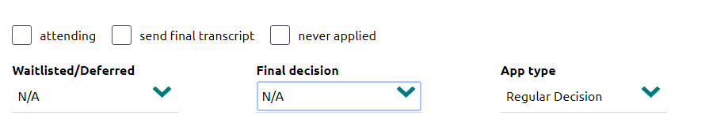
Check if you did not complete the application process
If you are adding schools, you need to indicate how you applied. If applying to NOVA, you should choose Rolling as the type
Unknown – Do not use

Accepted - You received an acceptance letter from that school or you are applying to a community college such as Northern Virginia Community College

Denied - You received a denial letter

Guaranteed Transfer – Do not use

Withdrawn – You withdrew your completed application before the college decision was made

Conditionally Accept - You have been accepted, but must meet defined requirements other than completion of coursework and final transcript before you are enrolled

January Admit - You received an acceptance letter requiring a January start date at the college

No Decision - You have completed the application process but have not yet received a decision from the college

Incomplete -You requested a transcript, but did not complete the application; make sure you also check the “never applied” box (above the Final decision box)

Summer Admit - You received an acceptance letter requiring a summer start at the college

Select only if you applied early but were deferred until regular decision, or you were put on the waitlist.

Even though you have checked attending, if you have not also checked send final transcript, your final transcript will not be automatically sent to your attending school.
Question 3. FAFSA – It is okay to choose “unsure” if you do not know if the FAFSA forms have been completed by your parent(s) or guardian(s).

Question 4. This question refers to need-based federal government aid that does not have to be paid back, such as a Pell grant. It is okay to choose “unsure” if you do not know the answer.

Question 5. This is scholarship money you have been offered, but do not include GI Bill, Yellow Ribbon Program, loans, or TAG money. If you are attending a service academy, such as the Air Force Academy or West Point, you will answer yes to this question.

Question 6. Total amount of scholarship money you are accepting and using. If you are attending a service academy (e.g. Coast Guard Academy, Naval Academy) ask Ms. Kim to provide you with the total scholarship dollars. If the scholarship is renewable, multiply the amount by the number of years it will be offered to you. Do not use commas or dollar signs. Do not include GI Bill, Yellow Ribbon, loans, or TAG money. On the FHS Senior Survey you will list these scholarships individually.

Question 7. Check as many boxes that apply to you. You must check at least one box.

Question 8. This question is OPTIONAL and does not need to be answered.

- DO NOT HIT SUBMIT YET. CHECK YOUR ANSWERS, MAKING SURE YOU HAVE CHECKED A “SEND FINAL TRANSCRIPT” BOX FOR THE SCHOOL YOU ARE ATTENDING.
- Once you hit submit, you cannot go back and change your answers. Please check your school email daily.
- If Mrs. Scibilia has a question about one of your answers, they will send you an email.

Thank you!

