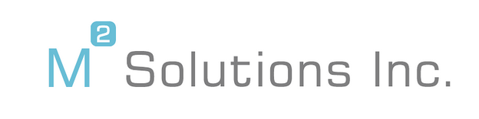
2023 SCHOLARSHIP
Fairfax High School, Fairfax, VA

M2 Solutions, Inc., a technology company located in Northern Virginia, will offer a $1,500 scholarship to support a disadvantaged high school senior who is pursuing community college, technical school, or four-year university, and plans to pursue a career in the STEM field. There may also be opportunities for mentorship and/or an internship for the student who is awarded this scholarship.
To be eligible for this scholarship, you must:
- Be a graduating senior of Fairfax High School in Fairfax, VA
- Have a minimum GPA of 3.0 or higher.

To apply:

- You MUST include your full name, home address, email address, and phone number in your submission.
- Write a short autobiography including information about your family, work experience, community involvement, hobbies, spare time activities, and what you hope to do in the future.
- Include a short summary or personal statement describing your accomplishments and goals.
- List any honors and awards you’ve received.
- List any extra-curricular activities.

Applications are due by Friday, April 21st and should be submitted to ADMIN@m2solutions-inc.com. 2023 Fairfax High School Scholarship should be in the subject line.

Latina students are strongly encouraged to apply.

